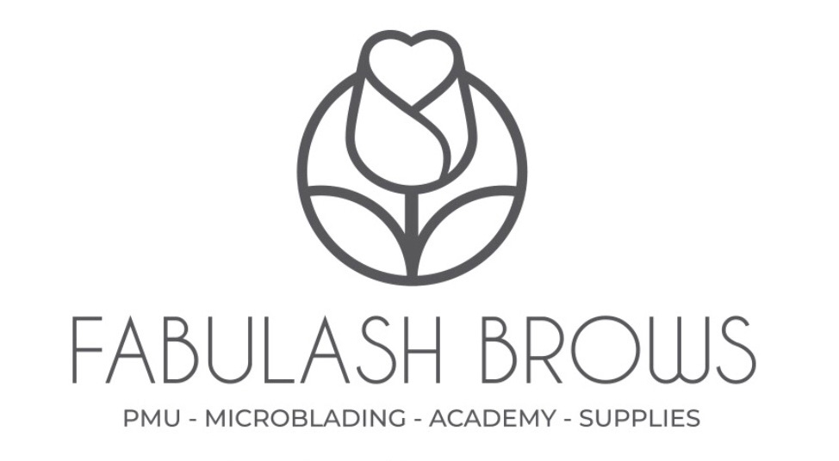

SEMI-PERMANENT MAKEUP BEFORE AND AFTER CARE

BEFORE THE TREATMENT

- SPMU treatment cannot be done whilst pregnant, breastfeeding, or while you have your period.
- No alcohol, caffeine, drugs, and medicines containing blood thinner ingredients 48 hours before the procedure.
- If you’re having brows done, make sure they are not tinted as this makes it harder for our technician to see your true eyebrow hair.
- Botox should be performed 3 weeks prior to or 3 weeks after the procedure.
- Microblading is not recommended for people with oily skin. If you have large pores or
oily/very oily skin, your results will appear softer/solid or powdered looking.
- If you are on medication, have any diseases or any kind of allergies, please check with your doctor before we can carry out the safe procedure.
- It’s recommended to exfoliate and moisturise the eyebrows/lips at home 2-3 days before the treatment day. This will help to soften the skin and help the colour penetrate into the skin easily.
- If you have cold sores and/or are prone to herpes (lip tattoo), you need to take medication 5-10 days before coming to the treatment. Please consult with your doctor/pharmacist for the medicine.

AFTER CARE

IN THE FIRST 24 HOURS
- Rinse the treatment area with warm water or neutral soap (baby’s) by using cotton pads, after that apply a very thin layer of Skin Candy (pawpaw cream, vaseline, etc).
- This procedure shall be repeated 3-5 times a day to prevent scab formation.
- For post-treatment care use only provided cream or pure Vaseline. Please do not use any other creams except the ones provided to you in order to prevent possible infections or allergic reactions.
IN THE FIRST 7 DAYS OR UNTIL FINAL HEALING
- The healing process takes 3-7 days and is different with each client.
- Apply Skin Candy 3-5 times a day.
- No makeup in the treatment area.
- The treatment area may appear uneven, dry, itchy, tender, red & irritated. It is normal.
- These symptoms will dissipate each day and vary on an individual basis.
- Avoid public bathing, sunbathing, tanning salon, sauna, beauty treatments, intense training accompanied by sweating (sports activities), and contacting with dust (household chores, etc.)
IN THE FIRST 30 DAYS
- Avoid laser treatment over the treated area (Fraxel laser, IPL), because they can destroy the pigment and cause burns.
- The use of antibiotics and hormonal therapy can lead to a faster fading. Always protect the treatment area from the sun.
- The healed colour will be 40% less dark. If you have microbladed brows, microblading strokes will be 10% to 15% shorter after 4 to 6 weeks. It is why we need the touch up session.

